We know that,

A confidence interval for population standard deviation, Sigma is

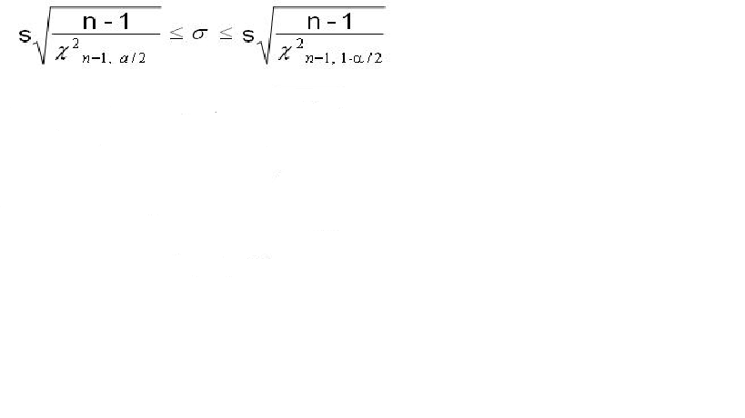

Therefore upper bound= sqrt((n-1)*s2 /Chisquare critcal)

Here d.f=n-1=14

Signiface level,α=0.05

> data=c(33.2,41.8,37.3,40.2,36.7,39.1,36.2,41.8,36,35.2,36.7,38.9,35.8,35.2,40.1)

> n=length(data);n

[1] 15

> s_2=var(data);s_2

[1] 6.612667

> critical_value=qchisq(p=0.975,df=14,lower.tail=FALSE);critical_value

[1] 5.628726

> Upper_bound=sqrt(((n-1)*s_2)/critical_value);Upper_bound

**[1] 4.055527**

> critical_value2=qchisq(p=0.025,df=14,lower.tail=FALSE);critical_value2

[1] 26.11895

> lower_bound=sqrt(((n-1)*s_2)/critical_value2);lower_bound

**>1.882671**

> Confidence_interval=c(lower_bound,Upper_bound);Confidence_interval

**[1] 1.882671 4.055527**

**Interpretation: The population standard deviation of pressure is lies between 1.882671 and 4.055527**